**WEEK 1 ASSIGNMENT**

NAME: SANJAY

REGNO: 20BCE0020

**FORM WITH CSS**

**OUTPUT**

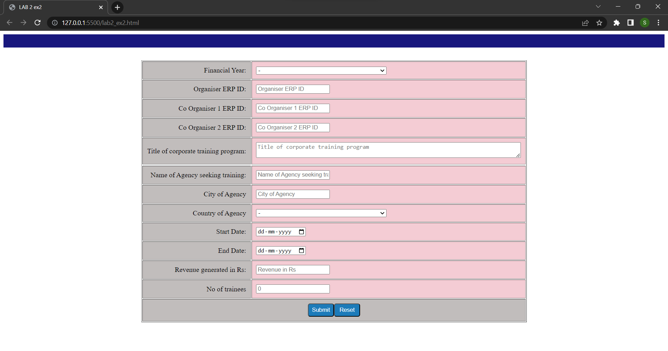

**CODE**

<!DOCTYPE html>

<html lang="en">

<head>

    <meta charset="UTF-8">

    <meta http-equiv="X-UA-Compatible" content="IE=edge">

    <meta name="viewport" content="width=device-width, initial-scale=1.0">

    <title>LAB 2 ex2</title>

    <style>

        .left

        {

            text-align:right;

            padding-right: 10px;

        }

        td{

            text-align: left;

            padding: 10px;

         background-color: rgb(193, 189, 189);

        }

        .top

        {

            background-color: rgb(23, 23, 126);

            width:100%;

            height: 30px;

        }

       .last

       {

        text-align: center;

       }

       select{

        width:300px;

       }

       table{

        margin-top: 30px;

       }

       .sub{

        background-color:rgb(29, 123, 185) ;

        color:white;

        width:60px;

        height:30px;

        border-radius: 5px;

       }

       th{

        background-color: rgb(68, 158, 197);

    }

    .c{

        background-color: rgb(244, 204, 211);

    }

</style>

</head>

<body>

    <form>

        <table align="center" border="1" cellpadding="10px" align="center">

            <div class="top"></div>

            <tr><td class="left">Financial Year:</td>

                <td class="c">

                    <select>

                        <option value="-">-</option>

                        <option value="2018">2018</option>

                        <option value="2019">2019</option>

                        <option value="2020">2020</option>

                        <option value="2021">2021</option>

                        <option value="2022">2022</option>

                    </select>

            </td>

        </tr>

        <tr><td class="left">Organiser ERP ID: </td><td class="c"><input type="text" placeholder="Organiser ERP ID"></td></tr>

        <tr><td class="left">Co Organiser 1 ERP ID: </td><td class="c"><input type="text" placeholder="Co Organiser 1 ERP ID"></td></tr>

        <tr><td class="left">Co Organiser 2 ERP ID: </td><td class="c"><input type="text" placeholder="Co Organiser 2 ERP ID"></td></tr>

        <tr><td class="left">Title of corporate training program:</td>

            <td class="c"><textarea placeholder="Title of corporate training program" cols="80" rows="2"></textarea></td></tr>

                <tr>

        <tr><td class="left">Name of Agency seeking training:</td><td class="c"><input type="text" placeholder="Name of Agency seeking training"></td></tr>

        <tr><td class="left">City of Agency</td><td class="c"><input type="text" placeholder="City of Agency"></td></tr>

        <tr><td class="left">Country of Agency</td>

        <td class="c">

            <select>

                <option value="-">-</option>

                <option value="india">India</option>

                <option value="us">USA</option>

            </select>

        </td></tr>

        <tr>

            <td class="left">Start Date:</td><td class="c"><input type="date" ></td>

        </tr>

        <tr><td class="left">End Date:</td><td class="c"><input type="date" ></td></tr>

        <tr><td class="left">Revenue generated in Rs:</td><td class="c"><input type="text" placeholder="Revenue in Rs"></td></tr>

        <tr><td class="left">No of trainees</td><td class="c"><input type="text" placeholder="0"></td></tr>

        <tr><td class="last" colspan="2"><input class="sub" type="Submit" value="Submit"><input type="reset" class="sub"></td></tr>

        </table>

    </body>

</html>